英语二参考答案
Section I Use of English
Read the following text. Choose the best word(s) for each numbered blank and mark A, B，C or D on the ANSWER SHET(10 points)
参考答案：
- C However
- D helps
- A solely
- A. Lowering
- C. reach
- A. Depiction
- D. due to
- C. Immediate
- B. Reasons
- D. instead
- A. track
- C.account for
- B. Adjust
- D. results
- B. Hungry
- C. Sign
- B. Decision
- D. Disappointing
- A. Because
- D. Obsessing

Section II Reading Comprehension
Part A
Directions：
Read the following four texts. Answer the questions after each text by choosing A, B，C or D. Mark your answer on the ANSWER SHEET (40 points)
Text 1
参考答案：
- A foster a child's moral development
- D burdensome
- B an emotion can play opposing roles
- B. can result from either sympathy or guilt
- D. wrongdoings
Text 2
参考答案：
- D. forests may become a potential threat
- D.lower their present carbon- absorbing capacity
- B. reduce the density of some of its forest
- A. To handle the areas in serious danger first
- C. Supportive

Text 3

参考答案：
- C. Flaws in U.S. immigration rules for farm workers
- D. the aging of immigrant farm workers
- B. To get native U.S. workers back to farming
- A. slow granting procedures
- B. Import Food or Labor?

Text 4

参考答案：
- B. urge consumers to cut the use of plastics
- B. prevent us from making further efforts
- D: We should press our government to lead the combat
- D: a top-down process
- C: are far from sufficient
Part B
Directions:
You are going to read a list of headings and a text. Choose the most suitable heading from the list A-G for each numbered paragraph (41-45). Mark your answers on the ANSWER SHEET.(10 points)
参考答案：
- A 42. D 43. C 44. G 45. F

Section II Translation
46.Directions:
Translate the following text into Chinese. Write your translation neatly on the ANSWER SHEET. (15 points)
[参考译文]
我们很容易低估英国作家古米·哈利。他有着一种令人愉快的、可读的风格，有人认为这种风格任何人都可以模仿得来。很多次我听到人们说:“我能写一本书，我只是没时间。”说起来容易，做起来难。然面与大家通常所想的不同，正如吉米:哈利所言，他在早年觉得“尝试写作游戏"并非易事。显然，即便他极具写作天赋，哈利呈现给这个世界的作品也是经过多年的练习、重写、阅读并且经过润色之后才得以形成的。与大多数作家一样，一路走来，吉米·哈利不得不经受多次的失望与拒绝，但是这一切更坚定了他获取成功的决心。他生命中所取得的一切，都是依靠自己艰苦的努力所获得的。他在文学领域的成功也不例外。
Section IV Writing
Part A
Directions: Suppose professor Smith ask you to plan a debate on the theme of city traffic, write an email to him.
- Suggest a topic and with your reasons,
- And your arrangement,
You should write about 100 words on the ANSWER SHEET.
Don't use your own name, use "Zhang Wei"instead. Don't write your address.(10 points)
【参考范文】
Dear Prof. Smith,
It’s my pleasure to plan the debate on city traffic, and I am writing mainly to put forward advice on the topic of this debate and introduce my preliminary arrangements concerned.
To begin with, the debate can be conducted with the topic of “By Bus or By Bike” on the ground that a host of residents prefer convenient vehicles to reduce time cost under the background of increasingly heavy city traffic. Therefore, the participants in this debate can take an active part in it due to their real experience in daily life. Regarding the arrangements of the debate, it will be held in the auditorium on our campus Dec.28th,2018. Anyone interested in this debate can apply for participation at the Students’ Union Office before Dec. 24th. Finally, a watch will be awarded to the winner of the debate .
It will be highly appreciated if you could give me an early reply or some comments on my plan.
Yours sincerely,
Zhang Wei
【参考范文译文】
尊敬的史密斯教授，
非常荣幸能够组织这次有关城市交通的辩论。我写信来主要是提议这次辩论的主题并介绍有关此次辩论的初步安排。
首先，这次辩论可以围绕“开车还是骑车”展开，因为在城市交通日益拥堵的背景下, 很多人更喜欢便捷的交通方式以节约时间成本。因此，这次辩论的参与者可以根据日常生活中的实际经验积极参与到辩论中来。关于这次辩论的安排：举办时间为2018年10月28日，地点在我校礼堂;获奖者会得到一块手表。
如
果您给早日回复我或者给我提一些建议和意见，我会非常感激。
您真诚的，
张伟

Part B
Directions:
Write an essay based on the following chart. In your essay, you should
1) interpret the chart, and
2) give your comments.
You should write about 150 words neatly on the ANSWER SHEET. (15 points)

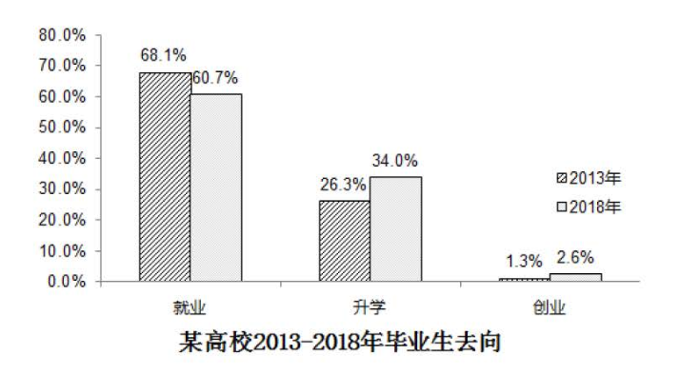

【参考范文】
This bar chart above looks into the choices that concern graduates most when they settle down after schooling. With the staggering economy, most graduates choose to find a job after they leave school, even though there is a decline of about 8 percentage in 2018, comparing that in 2013. The least part of them choose to establish their own business after graduation, with 1.3 percentage in 2013 and 2.6 percentage in 2018. As to the students who ask for further study, it accounts for 26.3 percentage in 2013 and 34 percentage in 2018. Besides, we can see from the chart that more students choose to continue to study instead of working after education，comparing those in 2013.
This reflects a change of attitudes of graduates towards life after schooling. I can find no better reasons for this phenomenon other than the following two. On the one hand, most graduates want to find a break after four-year study at school. This indicates that youth today are eager to face challenges and want to put what they have learned into practice. On the other hand, students are facing an ever intense competition owing to the expansion of enrollment. Most students have to do their further study. Hardly can such students find favorable jobs.
It is high time that we took effective measures to solve the problem. For one thing, it is essential that proper polices be worked out to promote students’ to run their own business. For another, students should be educated to get well-prepared for their future work. Only with this measure can our society improve for a sound development.
【参考范文译文】
以上的柱形图分析了高校毕业生在毕业后的选择。随着经济的迅速发展，大多数的毕业生选择就业，尽管比较2013年的数据，2018年有8个百分点的下降。最少比例的大学生选择创业，其中百分之34比例的学生选择继续学习深造，另外，数据显示2018年选择继续深造的学生有上升的趋势。
上图的分析显示了大学生的生活态度和抉择。有两个因素可以解释这个现象。第一，大多数的毕业生想在毕业后不在学习而是进入工作状态。他们愿意接受更具有挑战的生活状态，把学习的知识实际用于生活。第二点，学生现在面临着更严峻的竞争环境。大多数学生无法找到心仪的工作，而不得不选择继续深造。
我们应该采取有效地措施来缓解这样的现象。首先，国家应该出具相应的政策来帮助学生自己创业。其次，学生们应该在学校期间做好充分的准备，才可以迎接毕业后的就业选择。只有这样，我们的社会才可以健康发展。

